Quizz1

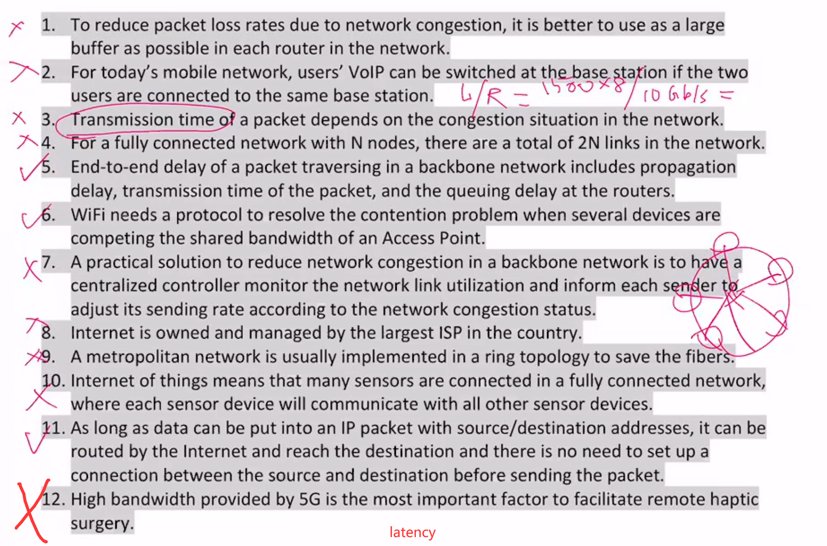

Quizz2

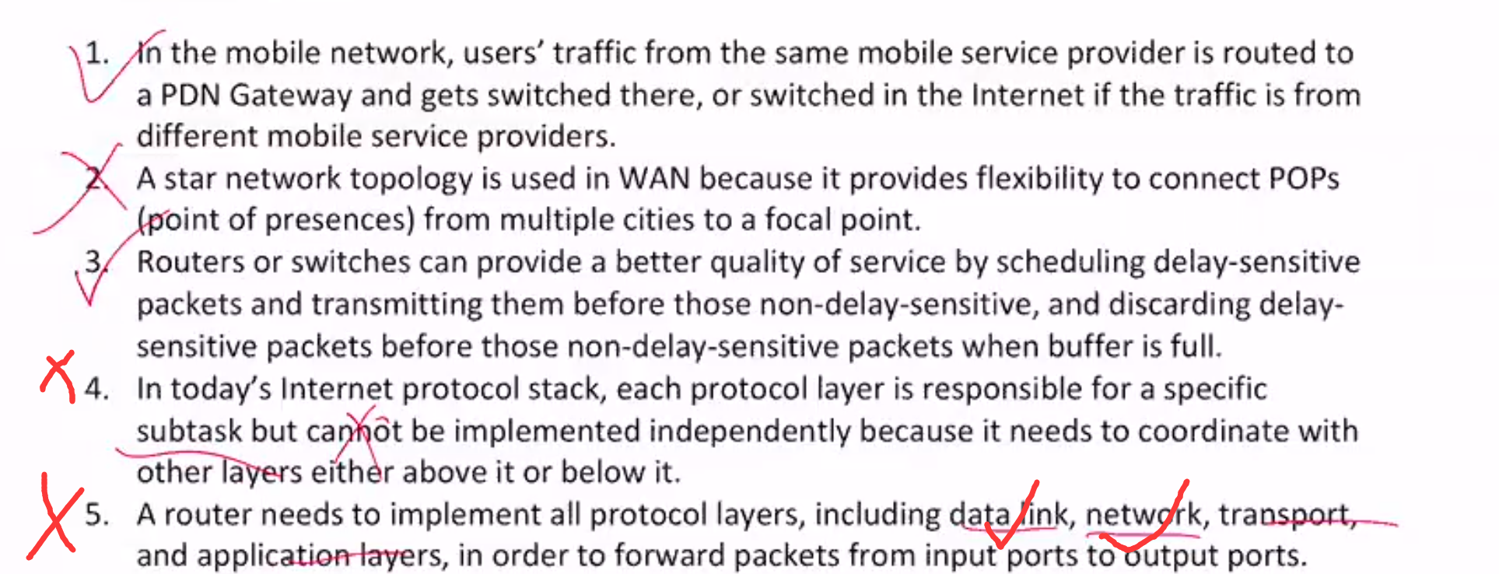

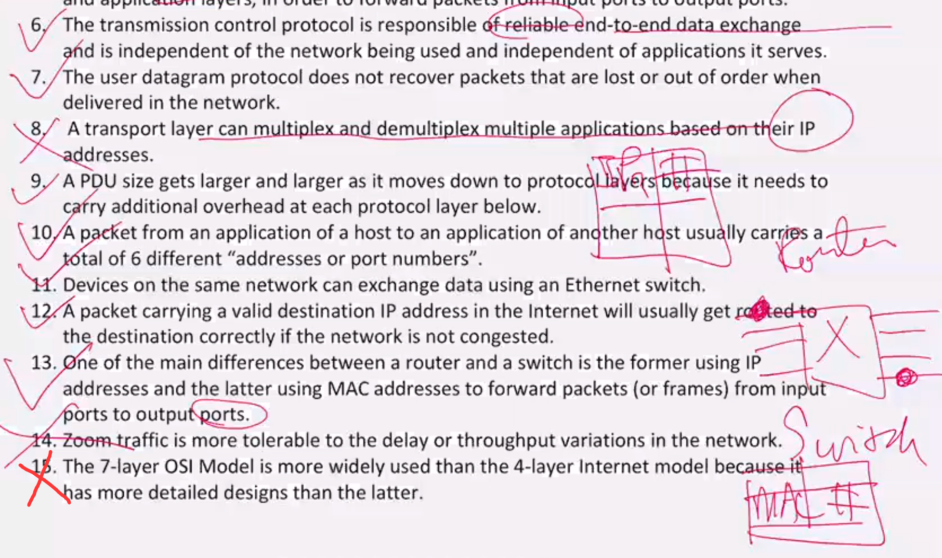

Quizz 3

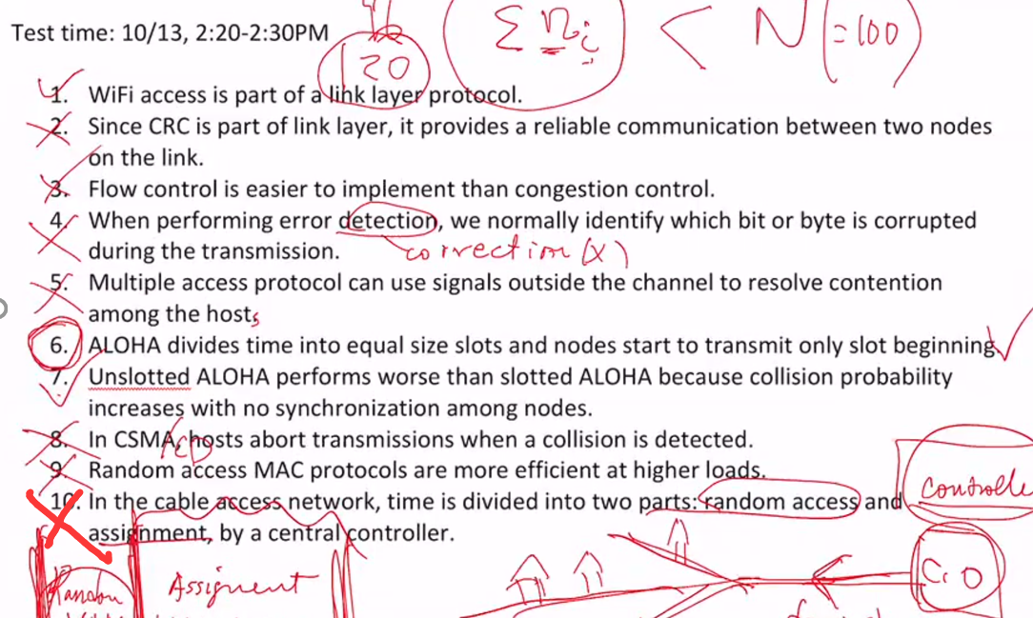

Quizz 4

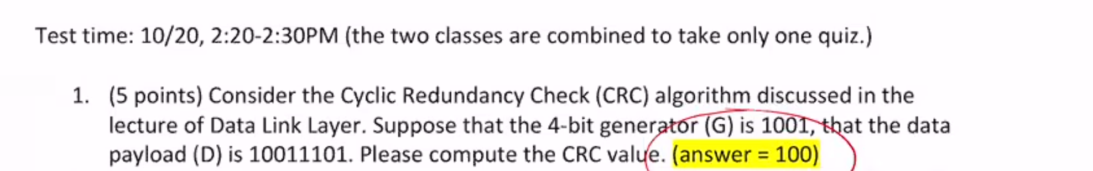

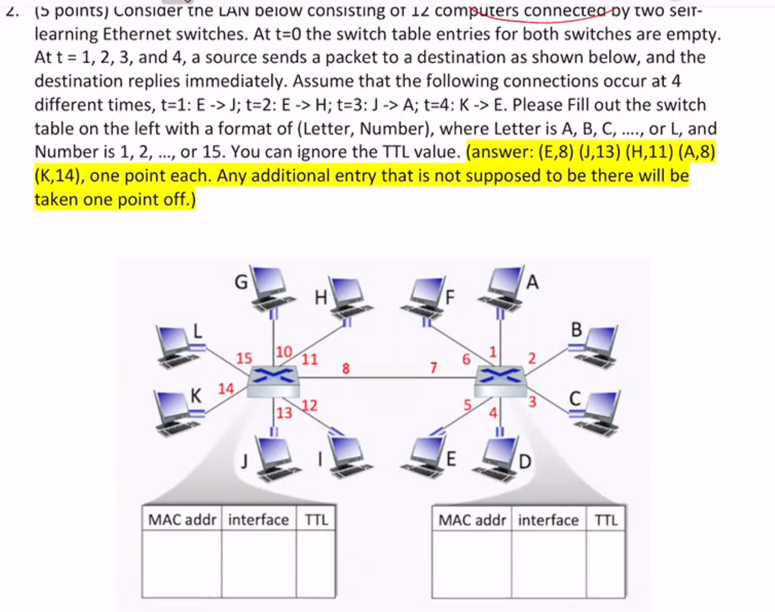

Quizz 5

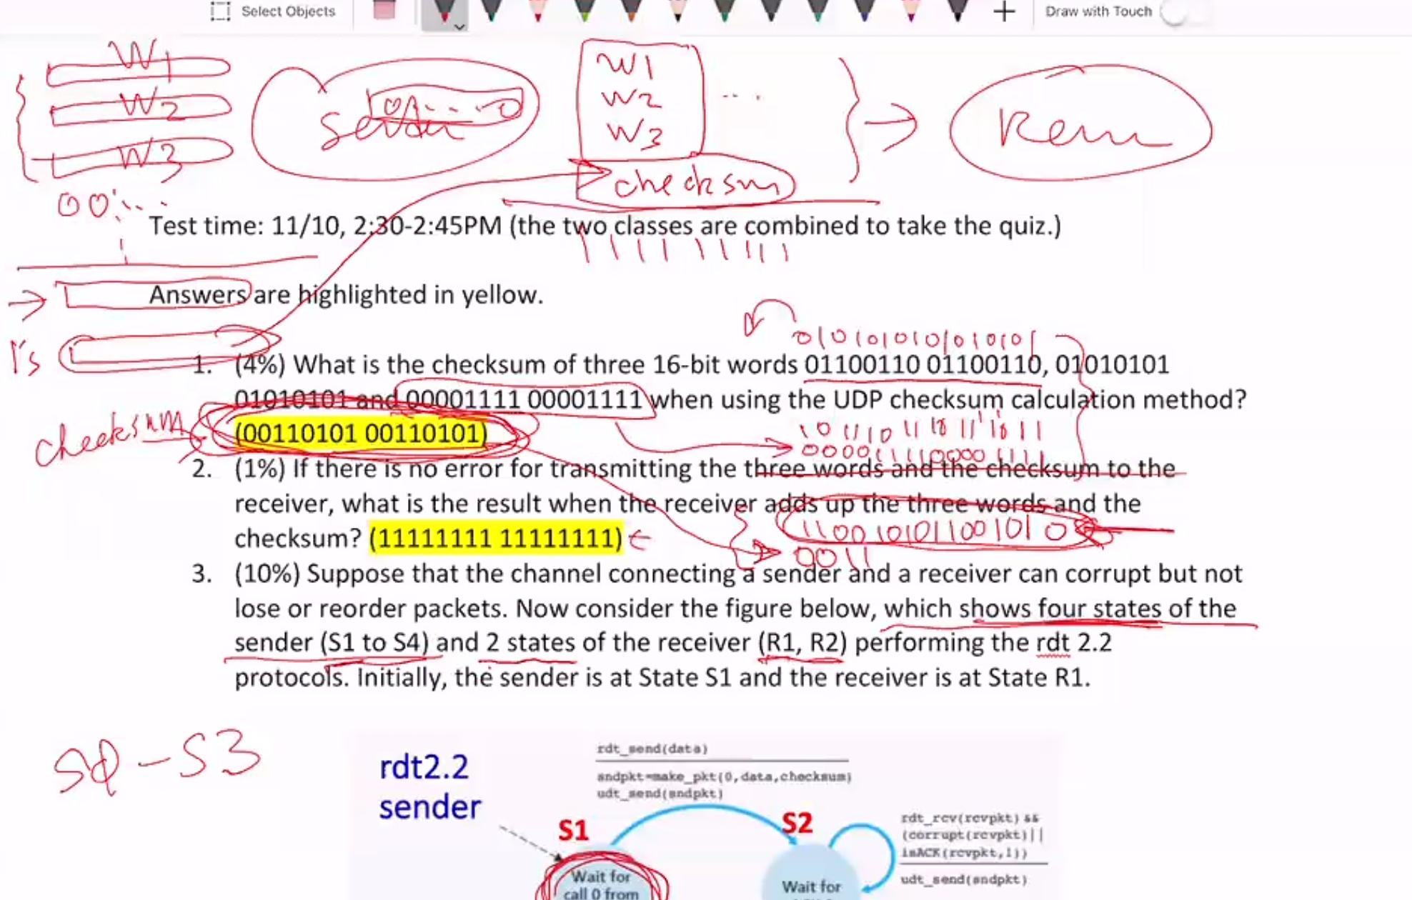

Quizz6&7

|  |  |
| --- | --- |
| quiz6/7 |  |
| Upon receiving 3 duplicated ACKs, the way of changing cwnd for Taho and Reno is the same. | F |
| Comparing the Reno and Cubic TCP schemes, the latter can probe available bandwidth in the network faster. | T |
| TCP congestion control is fair because it uses MIAD(AIMD | F |
| In the slow start mode, cwnd doubles for every returned ACK and in the congestion avoidance mod, cwnd doubles for every RTT. |  |
| One of the goals for congestion control is to make sure the buffer of a bottleneck link not empty but the occupancy as low as possible. | T |
| For TCP congestion control, only when arrival of in-order segment with expected seq # and all data up to expected seq # already ACKed, will the receiver wait for some time to send back a cumulative ACK. | T |
| For rdt3.0, when a receiver receives packet #0 with bit corrupted, it will immediately send ACK#1, which is equivalent to sending NACK#0 to the sender. | T |
| During the fast recovery mode, its cwnd increases the same as in the congestion avoidance mode. | F |
| Upon timeout, cwnd is always reduced to one, regardless in the slow start, congestion avoidance, or fast recovery mode. | T |
| For Go-Back-N retransmission scheme, there will be only one timer for the packet that was earliest sent. |  |
| When network congestion becomes so severe that the network could melt down, meaning that the throughput drops down to zero. | T |
| Network-assisted congestion control should perform better than end-end congestion control because the sender can detect the congestion situation earlier and response faster. |  |
| For the Go-Back-N retransmission scheme, upon timeout for packet n, a sender will retransmit packet n and all higher seq # packets in window. | T |
| For Selective Repeat scheme, each unACKed packet has a timer at the receiver and the ACK is immediately sent upon receiving a packet. |  |
| When entering the fast recovery mode, cwnd is reduced to a half of it plus 3, where plus 3 is because of 3 duplicated ACKs | T |
| When network congestion becomes so severe that the network could melt down, meaning that the throughput drops down to zero. |  |
| In TCP congestion control, hosts competing for the link bandwidth at a bottleneck link have the same throughput, independent of their distance from the bottleneck link. | F |
| Network-assisted congestion control should perform better than end-end congestion control because the sender can detect the congestion situation earlier and response faster. | T |
| 一开始多少，多少个N一起传能让utility达到100%   |  |  | | --- | --- | | 0.20% | 50000 | |  |
| For Go-Back-N retransmission scheme, there will be only one timer for the packet that was earliest sent.（but not ACKed | F |
| For TCP, a receiver can either keep or discard packets that arrive in out of order. |  |
| In the slow start mode, cwnd doubles for every returned ACK and in the congestion avoidance mod, cwnd doubles(+1 for every RTT. | F |
| For Selective Repeat scheme, each unACKed packet has a timer at the receiver(sender) and the ACK is immediately sent upon receiving a packet. | F |
| For TCP, a receiver can either keep or discard packets that arrive in out of order. | T |
| The purpose of using sequence numbers in rdt2.2 and rdt3.0 is for a receiver to find out whether an arriving packet contains new data or is a retransmission. | T |
| A connection between New York and San Francisco is on a 100 Gbit/s optical fiber. Let us only consider propagation delay for the latency between the two cities, and assume that the distance between the cities is 5,000 km and the light speed on the fiber is 2x108 m/sec. For the rdt 3.0 pipelined protocol, let us assume that a sender can send a window of 100 unACKed packets with each packet size of 1,250 bytes. The utilization on the link is 0.02. | F |
| For Selective Repeat scheme, given a window size of N, the minimum range for sequence numbers to avoid any error is 2N-1 | F |

Quizz8

黄的是对的

1.TCP have state

4. recursive load heavier

7.purpose is to reduce computation time

8.using its private key

9.a same set of keys

